CSV Octave Report

By: Ryan Nguyen

Abstract:

This report is a step by step documentation of how I learned to program the plotter, salter, and smoother using Octave. I used various resources to help me along the way. The final results are presented in the google sheets link here: [CSV Octave Report SpreadSheets](https://docs.google.com/spreadsheets/d/18L781wx9voSGS3NhNJlo2IgTRvYuFr85QAgE-B0RHgc/edit#gid=1429328724)

## Plotter

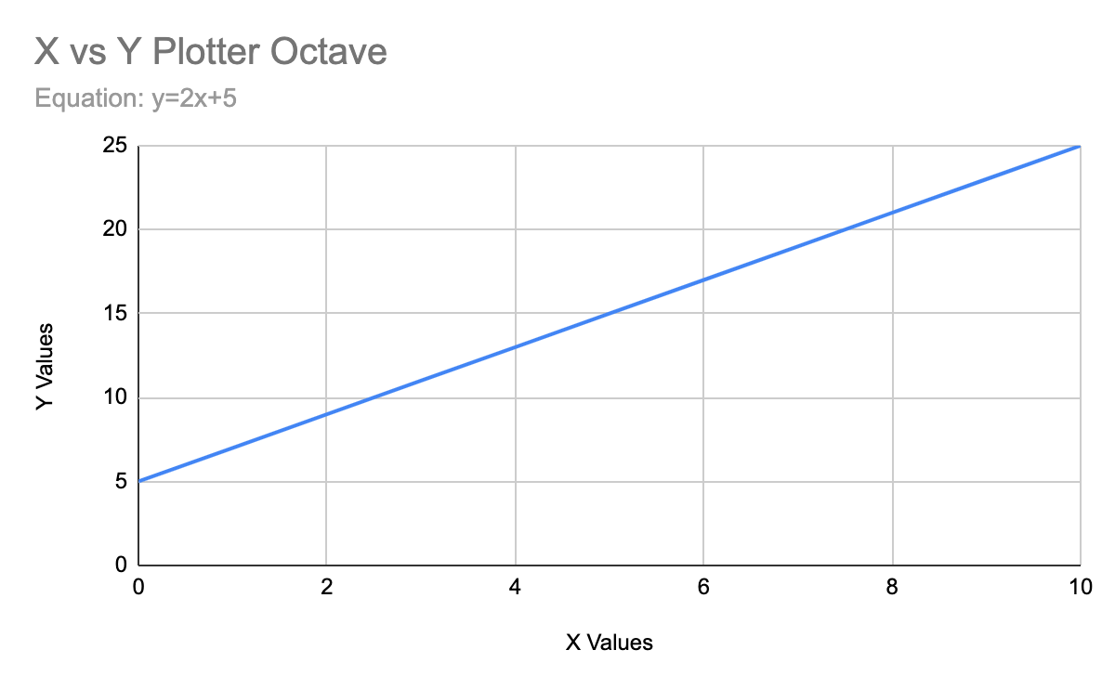

The first tutorial I used to figure out how to plot the graph was [How to edit plot using a MATLAB script](https://www.youtube.com/watch?v=Hfj6HtmfMpY). Using this format I was able to graph using Octave throughout the plotter, salter, and smoother. I was surprised how simple it was compared to using java because I thought I would be using bigger or unfamiliar commands. You can write the whole csv in one line.

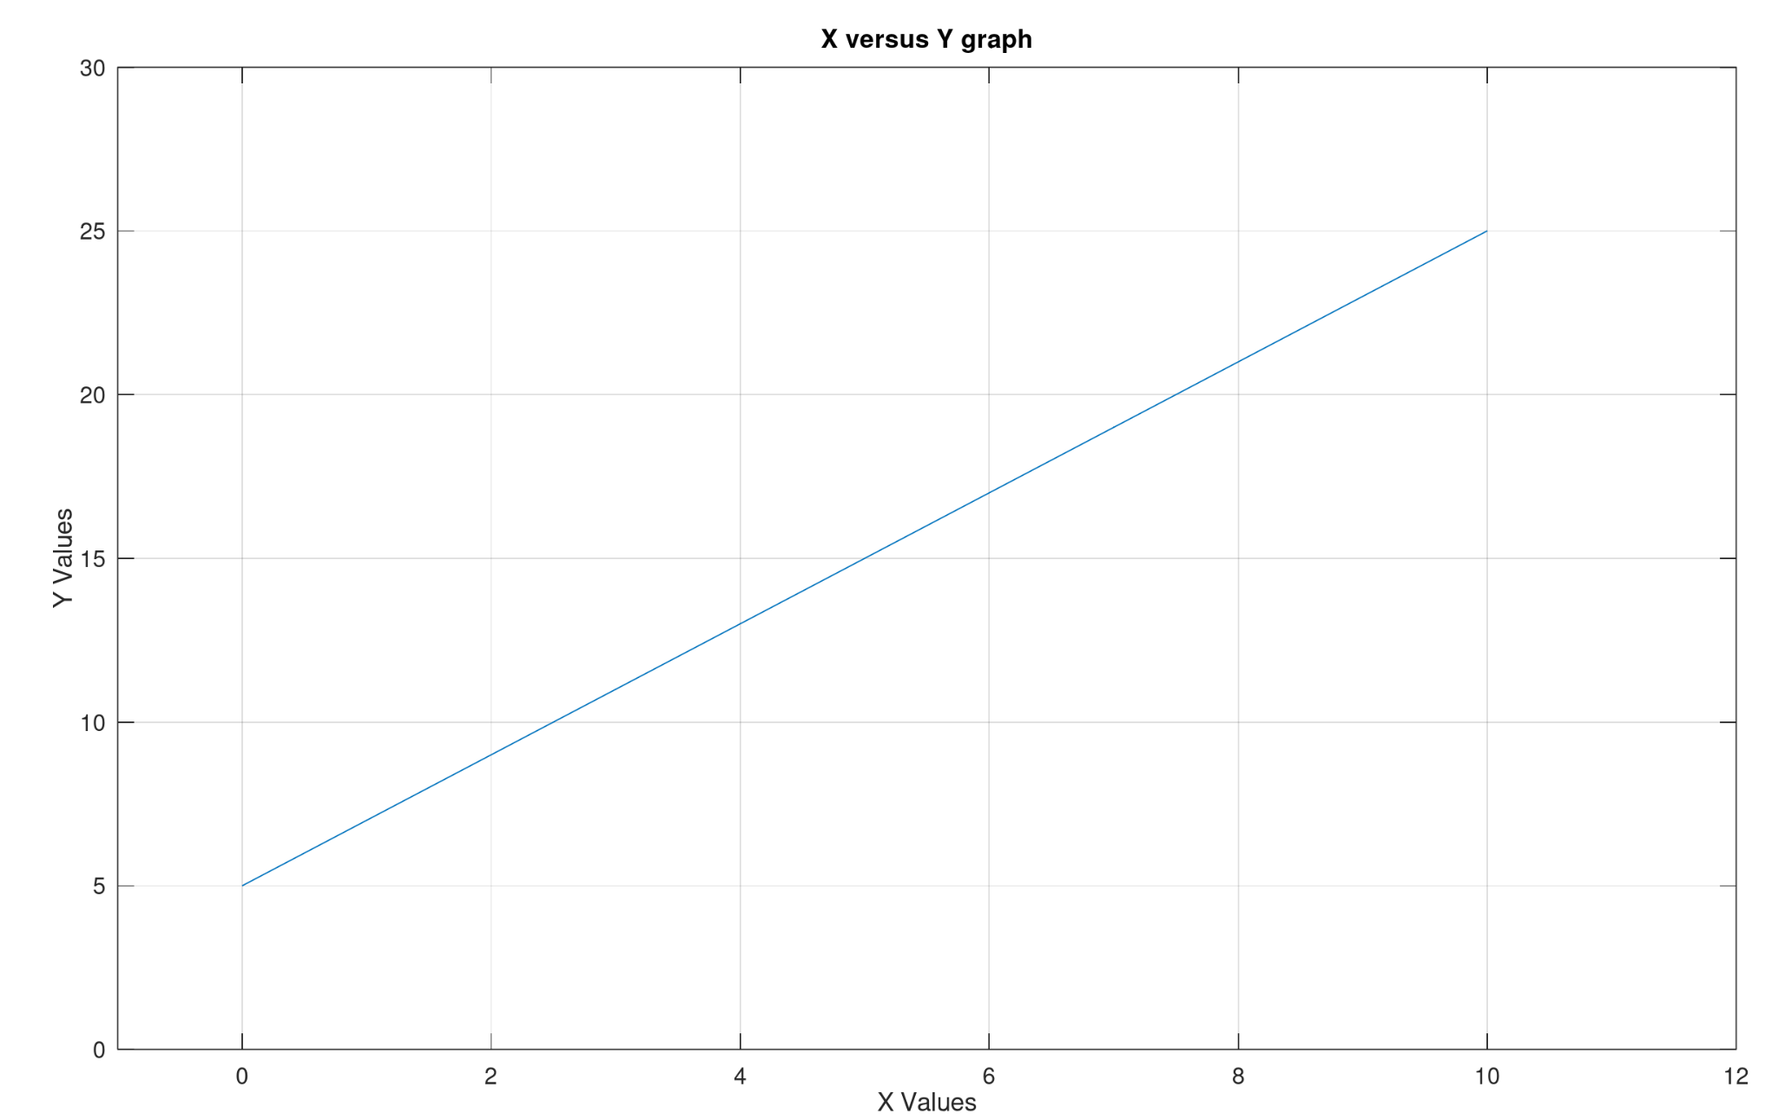

## Salter

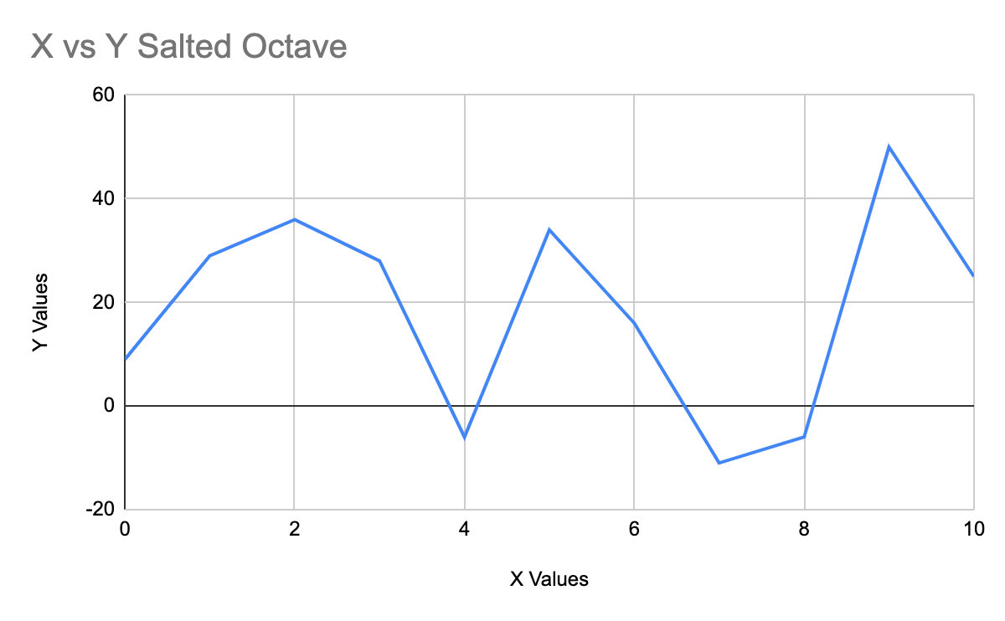

The salter was a little more difficult than the Plotter because like the Java csv files, I learning how to take the values out was confusing because the dataset goes in as one variable. You have to split the variable into 2 different series to get the x and y values. [Octave CSVRead [SONA & SEYHA]](https://www.youtube.com/watch?v=xdx-ck-Q9W8) Using this video I learned how to read the files and use a for loop to take the data out, but the video is in a Cambodian language so it was a little more difficult to learn. Getting a random variable and inputting it was easy though.

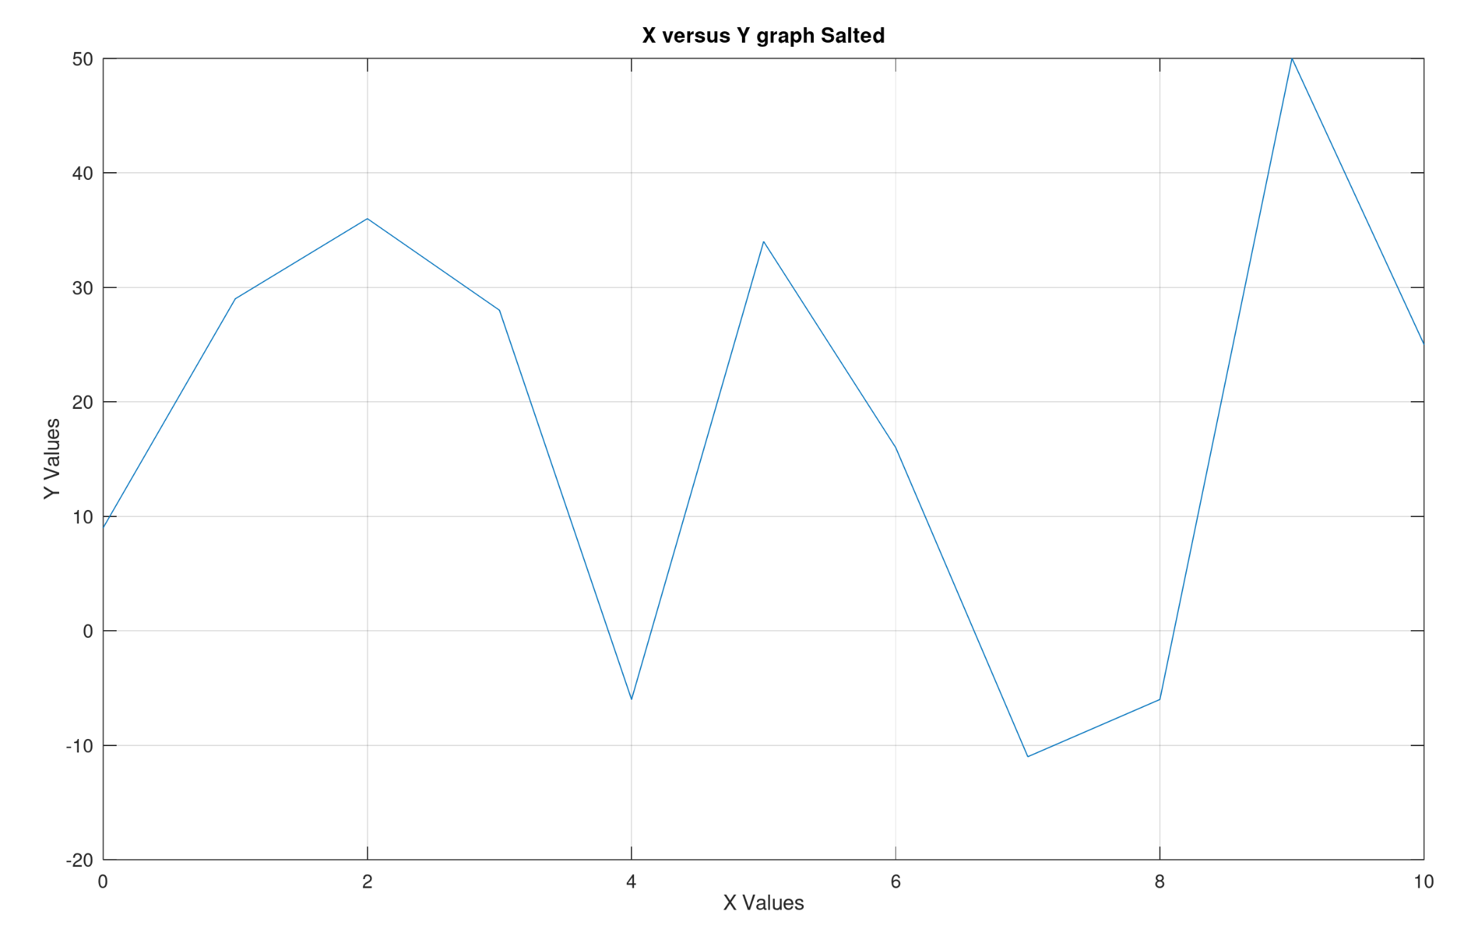

## Smoother

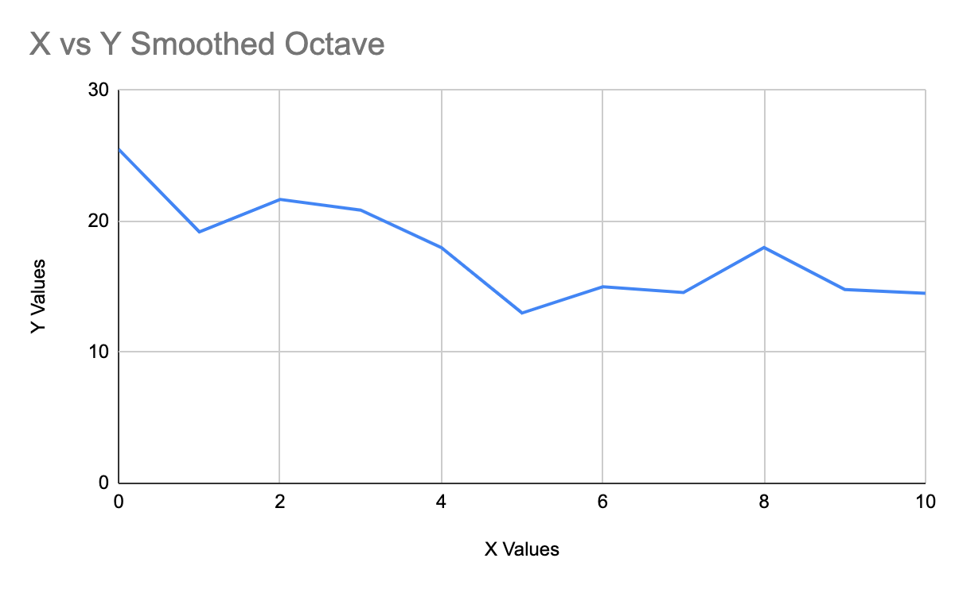

Smoothing was the most difficult because I am very unfamiliar with Octave. I had to make a simpler version of the smoothing code from Java. Making the for loop took me most of my time. Plotting and reading the graph was easy though.

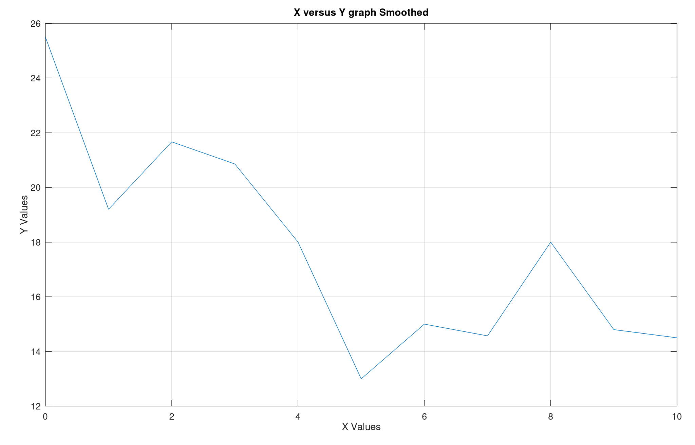

## Combined Graphs

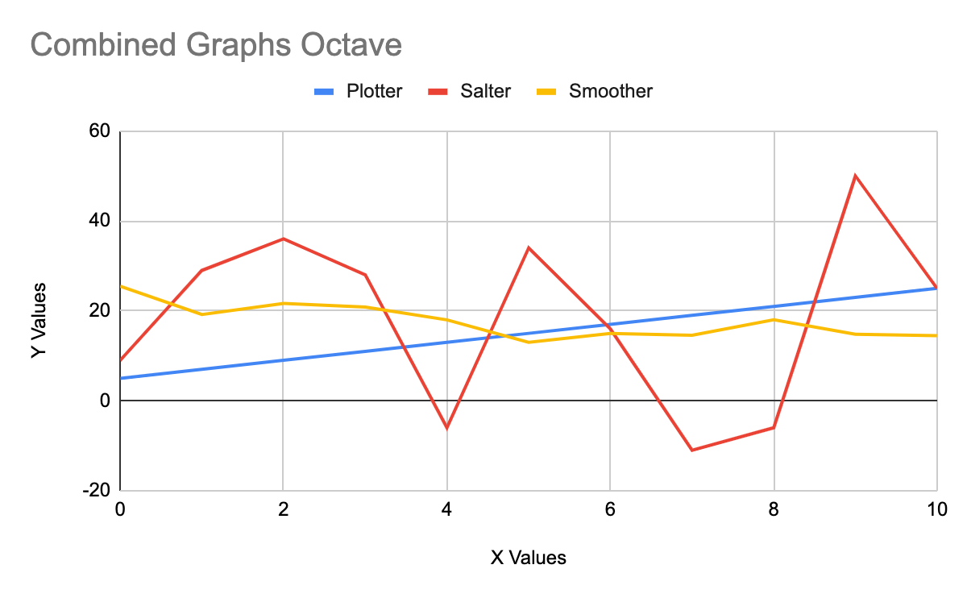

From the combined graphs we can view that the data created was correct. The graph is the same plotter graph as the Java program. The salted graph is within a -30 to 30 range around the plotter graph. The trend line of the smoother is also within the inside of the salted graph.